**MeshGrid and Linespace**

The purpose of meshgrid is to create a rectangular grid out of an array of x values and an array of y values.

The NumPy module of Python provides **meshgrid()** function for creating a rectangular grid with the help of the given 1-D arrays that represent the **Matrix indexing** or **Cartesian indexing**. MATLAB somewhat inspires the meshgrid() function.

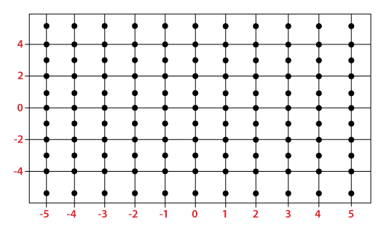

In the above figure, the x-axis is ranging from -5 to 5, and the y-axis is ranging from -5 to 5. So, there is a total of 121 points marked in the figure, each with x-coordinate and y-coordinate. For any line parallel to the x-axis, the x-coordinates of the marked points are -5, -4, -3, -2, -1, 0, 1, 2, 3, 4, and 5 respectively. On the other hand, for any line parallel to the y-axis, the y-coordinates of the marked points from bottom to top are -5, -4, -3, -2, -1, 0, 1, 2, 3, 4, and 5 respectively.